How Does Art Therapy and “Zentangle” Reduce Feelings of Stress and Anxiety?

By

Amelia Brown

A Project

Submitted to the

Art Therapy Program, College of Education

Wayne State University

Detroit, Michigan

In partial fulfillment of the requirements

For the degree of

MASTER OF EDUCATION or MASTER OF ARTS

YEAR

MAJOR: ART EDUCATION or COUNSELING

APPROVED BY:

Advisor Date

Abstract

In this art-based research, I explored the importance and relevance of using art therapy and “Zentangle” as treatment methods for stress and anxiety. This study data are from personal art therapy art-making, as well as observation of a peer performing the same art therapy techniques. Due to high anxiety and stress levels, many people seek new and innovative ways to cope. It has been proven that art therapy reduces anxiety and stress, but there are few studies published to back up said research (Abbing, et. al, 2019). With the advent of a world health pandemic due to the Covid-19 virus, art therapy techniques are something that people can do at home to cope with stress and anxiety. “Zentangle” art specifically requires little art supplies, and people can easily create them at home in seclusion. Although it can be argued that the popularity of adult coloring books and “Zentangle” workbooks indicate their effectiveness in stress reduction, there are few studies published that demonstrate the direct connection between “Zentangle” art making and reduced stress and anxiety (Abbing, et al., 2019). This art-based research contributes to the knowledge of whether and how “Zentangle” art reduces stress. The study is limited by the paucity of research available on “Zentangle” art, as well as the limitations inherent to ensuring quality and relevance of art-based research

Note: The word “Zentangle” appears in quotations in this research paper because I, the researcher, am not a certified Zentangle instructor. I have conducted art that mimics the “Zentangle” method, but I have not gone through the required training in order to effectively teach the methods of Zentangle.

**Introduction**

Using art therapy as a treatment and coping mechanism for stress and anxiety is important and interesting to me personally because I, among millions of other people in the United States, suffer from these two conditions on a daily basis. Art therapy is a non-verbal, experience-oriented therapy that uses visual arts (painting, drawing, sculpting, etc.) to facilitate therapeutic outcomes including reduction of anxiety, often in multidisciplinary treatment programs (Abbing, Baars, Sonneville, Ponstein, & Swaab, 2019). This is accomplished by creating distance from the anxiety and by regulating emotions (Abbing, et. al., 2019). Art therapy is also a useful tool for coping with stress related symptoms because it helps to provide a distraction from the negative emotions by using different techniques, one of them being mindfulness. Mindfulness interventions have been linked to the reduction of stress and anxiety (Schwarzer, et. al., n.d.). Mindfulness is the basic human ability to be fully present, aware of where we are and what we are doing, and not overly reactive or overwhelmed by what is going on around us (Jaret, et. al., 2019). Mindfulness is a quality that every human being already possesses and can be cultivated through demonstrated techniques—including meditation, yoga, or art (Jaret, et. al., 2019). There have been very few publications on the art of “Zentangle,” but the technique of Zentangle is appropriate for fostering mindfulness and reducing stress. “Zentangle” combines both meditation and art to create a way of meditation through drawing. This type of art therapy can be related to mandala making and coloring, as well as coloring pages and a myriad of other art therapy techniques. This helps the client focus on the here and now, which is very beneficial for people with high levels of stress and anxiety. This is important in the field of art therapy because stress and anxiety are two of the most prevalent issues in the mental health field, and anxiety disorders are one of the most diagnosed mental health disorders among adults in the United States (ADAA, 2018).

This study has become even more important as of late, as the world is under a global health pandemic due to the Covid-19 virus. Many people are stuck in seclusion, and in many states, including Michigan; people are under a stay-at-home order. This makes using many coping mechanisms much more difficult. That being said, art therapy is something that anyone can do in the seclusion of his or her own homes. Specifically, “Zentangle” requires very few art supplies, and can easily be done with just a pen and piece of paper, if one doesn’t have a thin marker. For many, every day life can be anxiety provoking and stressful, and now, in the time of a global health pandemic, many people have found themselves much more stressed than usual. Thus, coping mechanisms like art therapy, mindfulness, and meditation are critically important for the realities of today.

**Relevance**

According to the Anxiety and Depression Association of America, anxiety disorders are the most common mental illness in the U.S. They affect 40 million adults in the United States age 18 and older, or 18.1% of the population every year (ADAA, 2018). Despite their prevalence, anxiety disorders are highly treatable, yet only about 37% of those suffering with these disorders receive treatment (ADAA, 2018). This is very troubling, and is a good example of why art therapy and other expressive therapies need to be better implemented into every day life. Adults with anxiety disorders are also much more likely to suffer from a co-occurring disorder such as depression. Surprisingly, nearly one-half of those diagnosed with depression are also diagnosed with an anxiety disorder (ADAA, 2018).

In addition to anxiety, stress is also on the rise in the U.S. According to the American Institute of Stress, about 83% of U.S. workers suffer from work related stress (AIS, 2018). In general, about 55% of Americans are stressed during the day, and Americans are among the most stressed populations in the world (American stress level is 20% higher than the world average of 35%) (AIS, 2018). Women are also more stressed than men, according to a survey by the American Psychological Association (APA, 2016). These statistics are alarming, especially because over one fourth of Americans said that workplace stress affected their personal relationships and home life (AIS).

Interestingly enough, searching Google for “Coronavirus Statistics,” reveals that the first reference is an article that is titled: “How to relieve stress?” This underscores how much our country, and the world, needs appropriate coping mechanisms right now, especially because people can’t do many of things they would normally do to cope with stress, such as going to the gym or out with friends. People cannot scroll through social media or watch the news without being bombarded with the new death toll from Covid-19, and that is very hard on everyone’s mental health. People need an accessible way to cope with all of the new stress and anxiety we have to face every day. Not only are businesses closed, but the fear of actually getting the virus is on everyone’s mind as well, of course. If one has an underlying health condition, even the common condition of asthma, the virus is even more deadly. Thus, the fear of dying is added to economic stress.

Art therapy techniques can be practiced at home, while people are in seclusion. “Zentangle” can be considered an art therapy technique that is among the most accessible given the minimal materials required: paper and a black pen. “Zentangle” is an easy-to-learn, relaxing, and fun way to create beautiful images by drawing structured patterns (Learn Zentangle, n.d.). These patterns consist of combinations of dots, lines, simple curves, S-curves, and orbs, and they are called “tangles” (Learn Zentangle, n.d. p.1). “Zentangle” is a non-representational and unplanned art form that lets the artist focus on each stroke and not worry about the result (Learn Zentangle, n.d. p.1). Rick Roberts and Maria Thomas created “The Zentangle Method” by combining meditation and calligraphy (Learn Zentangle, n.d.). One day, Maria told Rick about how practicing these intricate designs in the background of her calligraphy put her into a flow-like state. This included feelings of “selflessness, timelessness, effortlessness, and a rich immersion in what she was doing” (About the zentangle method, n.d. p.1). This is when Rick noted that she was also describing mediation. Thus, “Zentangle” was born. The “Zentangle” method involves using pattern drawing to enter a state of mindfulness and flow (Schwarzer, et. al. n.d). On the official Zentangle website (www.zentangle.com), there is an extensive list of benefits the authors claim can be achieved through the “Zentangle” method: one can “relax, focus, expand your imagination, trust your creativity, increase your awareness, respond confidently to the unexpected, discover the fun and healing in creative expression, feel gratitude and appreciation for this beautiful world and all that you can do, and most importantly: have fun!” (Learn Zentangle, n.d., p.1). In other words, this is something that everyone needs to add to their tool belt of coping methods.

**Literature Review**

  There are two strong themes that emerged during my research into this question: How does art therapy and “Zentangle” reduce feelings of stress and anxiety? These themes are: 1) art therapy for stress, anxiety, and anxiety disorders, and 2) coloring and art therapy. Additional themes may arise in the future as more research is conducted.

**Art Therapy for Stress, Anxiety, and Anxiety Disorders**

Anxiety disorders are among the most diagnosed mental health disorders in the adult population, therefore need to be studied more often to yield more effective treatments (Abbing, et.al., 2018). Art therapy has been shown to be an effective treatment for these anxiety disorders, either among other therapies (talk therapy, medication) or as a stand-alone method (Abbing, et.al., 2018). Anxiety disorders affect 18.1 % of the U.S. population and is the number one mental health concern for women and the second for men (Ashlock, Miller-Perrin, & Krumrei-Mancuso, 2018). For a lot of people with anxiety, non-verbal, experiential therapies like art therapy are also easier than verbal communication. One small piece of art therapy includes making mandalas. Some evidence is also available that supports the role of creating mandalas to positively affect psychological well being and mood (Ashlock, Miller-Perrin, & Krumrei-Mancuso, 2018). When mandala making was compared to other coloring activities, it was found that the circular pattern of mandalas improved mood more effectively than other shapes, and adult coloring books use a lot of mandala-looking images on their pages (Ashlock, Miller-Perrin, & Krumrei-Mancuso, 2018). Therefore, coloring images in adult coloring books might have the same positive effect on mood. This suggests that both coloring and mandala making among “Zentangle” techniques may reduce stress and anxiety and improve mood in adults. This last statement then leads us right into our second theme, coloring and art therapy.

**Coloring and Art Therapy**

Coloring and art therapy are helpful for adults because it promotes creative mindfulness. Studies suggest that coloring is beneficial because it fosters mindfulness by engaging in a structured, detailed activity that also allows for some creativity (Ashlock, Miller-Perrin, & Krumrei-Mancuso, 2018, p. 197). Coloring may also be a manner of achieving flow and may bring on a mindful, meditative, or attentive state (Flett, Lie, Riordan, Thompson, Conner, & Hayne, 2017, p. 410). Studies show that coloring mandala and plaid designs showed greater anxiety reduction than just drawing freely (Flett, et. al., 2017). This might also be because many adults don’t see themselves as artists, so drawing freely may cause some anxiety. They may feel that they cannot draw, or that they don’t know what to draw. Studies also show that anxiety reduction can be achieved after just one coloring session (Flett, et. al., 2017). Research also suggests that the reason that coloring a predesigned mandala as opposed to making a free drawing is due to the “distraction effect” which maintains the participants’ attention, and thus distracts them from thinking about their anxiety (Lee, 2018). “Zentangle” also induces mindfulness by having the client focus on the intricate designs that the meditative art requires. Mindfulness and art therapy go hand in hand when reducing stress and anxiety.

Coloring and art therapy are both highly accessible, and art materials required are minimal (Flett, et. al., 2017). Coloring is also easily implemented into everyday life and both children and adults can partake easily (Flett, et. al., 2017). “Zentangle” is also easily accessible and only requires a .01-micron pen (or any thin drawing utensil) and (usually white) paper. This is a very important piece of the puzzle, especially if someone is stuck in seclusion at home, and is looking for an easy coping mechanism.

**Data Collection, Analysis, and Structure**

The researcher typically conducts his or her own art-based research or artwork, but art based methods can include the observation of someone else’s art. The first step in ABR research is to determine a research topic that is interesting or aesthetically pleasing to the researcher. I decided to research art therapy and “Zentangle” art. I chose to research art therapy because I am in my final year of my Master’s education in art therapy, and I decided to include “Zentangle” art because it was an interesting new type of art that I didn’t know much about, but had been seeing here and there. I found it interesting because it was very intricate, and seemed like a lot of work to learn, but I was up for the challenge.

Next, the researcher conducts the required research on the idea, to figure out the background and similar studies that have been conducted previously. The researcher looks into what has already been learned about the subject in question, and what still needs to be learned. I didn’t find too much background on “Zentangle,” because it is a fairly new technique. I found much more research on art therapy, but still no substantial number of publications. After reading published literature and studies on the topic, the researcher completes artwork. This includes making art and observing what they make. I did this by creating “Zentangle” art at my place of work, which is an Independent Living Facility for seniors, alongside a peer and some residents. I run activities there, so I created a new “class” for residents to come and learn how to make “Zentangles” if they were interested. The “classes” were once a week, and lasted anywhere from 30 minutes to an hour. I have to put “classes” in quotations because I am not a certified Zentangle instructor, so I technically don’t teach the Zentangle Method. I had about 3 or 4 residents at each “class”. We worked through the Zentangle book I had and learned how to make each different tangle. Everyone who came to create “Zentangle” art with me really enjoyed learning the different tangles and how to create each art piece, as did I. Some of the tangles were a little bit difficult for them to learn, but if they were interested enough they continued to come to the class to learn. Eventually the interest in the class died off and it was just Ben and I every week, so after a while we stopped the class.

During these classes, I also worked with Ben. We worked together during these sessions, and also on our own separately. I worked with Ben a lot more often than my residents. We met once a week with the other residents, and several other times outside of the regularly scheduled sessions. We did this for about three months before both of his parents passed. Afterward, we didn’t meet again because he was busy with other things, and we met exclusively at the senior living facility where they used to live.

After the artwork is completed, the researcher reevaluates the art piece(s) that they created, to analyze the value or effectiveness of the expression (Kapitan, 2018). This is the “re” in research, where the artist takes a backward glance at what they created; and this is called appreciation and discrimination (Kapitan, 2018). I did this part of the research by re-evaluating my “Zentangle” art, and also learning embroidery. The embroidery is important here because it reminded me a lot of the structure of “Zentangle” art, and could also be used in art therapy. I can now teach others now to do both “Zentangle” based art, and also embroidery. The final step in Art-Based Research is to publish my findings, and possibly display the art in a public location that will make the research available for others to view, which is partially being fulfilled in this final Masters essay (Kapitan, 2018).

**Methods**

My study uses Art-Based Research (ABR), in which art is the basis of inquiry. Art-Based Research can be defined as “the systematic use of the artistic process, the actual making of artistic expressions in all of the different forms of the arts, as a primary way of understanding and examining experience by both researchers and the people that they involve in their studies” (McNiff, 2008, p. 29). ABR is used in investigations where art plays a significant role in research, but it cannot be used in every situation involving art and art therapy. Since artistic expression is essentially heuristic, introspective, and deeply personal, there needs to be a complementary focus in Art-Based Research on how the work can be of use to others and how it connects to practices in the discipline (McNiff, 2008). This method can be really inspiring for so many different research questions. ABR is unique and so necessary in the field of art therapy. This type of research is appropriate in this particular study because there are few studies published about art therapy, and even fewer about the “Zentangle” method. There is a myriad of different ways to conduct Art-Based Research. The most basic steps are: 1) Research, 2) Practice, and 3) Reflection.

**Research**

The first phase of Art-Based Research consists of finding articles to inform the research question, which is: How does art therapy and “Zentangle” reduce feelings of stress and anxiety? I first searched for scholarly articles and ABR studies using Wayne State University’s online databases including ProQuest, Psych Articles and Psych Info; and I also utilized Google Scholar. Keywords included in the search were combinations of the following: art therapy, Zentangle, mindfulness, stress, anxiety, drawing, stress reduction, mandala, anxiety reduction, and meditation. From there, I narrowed the results down to just peer-reviewed scholarly articles, with full texts available online. I did not place any time restrictions on the search, which produced articles from the past 11 years (2008-2019). From these research articles I chose the few that were the most relevant to my research question. I used articles that ranged from actual studies conducted to other Masters thesis papers. I also found a few different studies that used Art-Based Research specifically, in order to model my study off of one that was already published, in order to ensure that I had all of the correct parts in an order that made sense.

**Practice**

For this project I made “Zentangle” art alongside a peer, Ben. I took into consideration how I felt before and after each session, and I also did the same with Ben, asking him how he was feeling after we completed each session. I tried to really observe how I felt even during the art making. I didn’t have much experience with “Zentangle” art, so this was all new to me as well. I enjoyed that I was learning something as well as reaping the benefits of therapeutic art making. I remember being sort of anxious at the beginning of each piece, not sure which direction I was going with it. Once I picked a direction, it was easy to come up with a plan and the designs kind of started to flow out onto the page. Each “Zentangle” came out differently than the last, which was amazing. I kept a “cheat sheet” nearby if I needed inspiration for which type of tangle to use next. They were just pieces of paper on which I had practiced each tangle beforehand, as we went through the book. Ben and I both used them. I think it took the pressure off not knowing which direction to head next. I also observed Ben’s demeanor before, during, and after art making. A lot of the time, I would observe him breathing a sigh of relief once the “Zentangle” was finished. This was proof in itself that it was working. I also had Ben complete a Hamilton Anxiety Rating Scale (HAM-A) at the beginning and end of our sessions, which showed some decrease in anxiety after art making. The HAM-A is a self-report questionnaire that determines how much anxiety the client is feeling at the time, and is used to assess how the client is responding to treatment. I didn’t fill one out, because I didn’t feel that it would be beneficial for me personally.

After practicing “Zentangle” art on paper for a while, I decided to teach myself embroidery. This was my response to learning the “Zentangle” Method. I wanted to know whether the non-forgiving ink media and small pieces were the therapeutic qualities I experienced by immersing myself in other small pieces requiring specific lines. I primarily used the Internet and YouTube to learn each different stitching method. I found that embroidery is a lot like “Zentangle” art, because there are a lot of planned strokes (stitches) and it is a type of art that I am not used to making. Most of my previous art was a lot of free flowing acrylic painting and oil pastels, so this was a new challenge for me. I haven’t made many structured art pieces before my study started with “Zentangle” art. I found that structured art making can be just as soothing and stress reducing as free flowing art. I never experienced this for myself before, so it was an amazing experience to feel the satisfaction of creating something planned and having it be therapeutic as well. I continue to learn to do embroidery, although I haven’t done much “Zentangle” since starting this study.

**Reflection**

The final phase in Art-Based Research is interpreting the art that was made by responding to and reflecting on it. This could include thinking about it, writing about it, or making more art! Art wise, I reflected on my “Zentangle” art by learning embroidery, which helped open my eyes to more structured art (as mentioned above). I would never have thought that this type of art could be so stress relieving. It really takes my mind off of everything going on around me and makes me focus on what I’m doing, and that in itself reduces stress and anxiety, in my opinion. While engaging in “Zentangle” or embroidery, I don’t have time to actively stress about other things, because I am focused on that next stroke or stitch. I think that this type of mindfulness is so important in reducing feelings of stress and anxiety.

When I interviewed Ben about his “Zentangle” experience, he had similar things to say about everything else around him being drowned out, and just focusing on the task at hand. He had nothing but positive remarks about the “Zentangle” Method and the art therapy process. Also, completing something and having that feeling of satisfaction was something that was important to him (and me as well).

Art-Based Research is built on lived experience through art expression, experiences, and viewing. In this study, art making was used to experience how “Zentangle” and art therapy can be used to reduce feelings of stress and anxiety. I believe through personal experience, research, and observation, that this is something that could be expanded on and used in the future. This is especially true at the time of this writing, during the global health pandemic of 2020. I believe that art therapy and teletherapy are going to grow tremendously this year, and a lot of people will benefit from these practices in the future.

**Personal Experiences and Findings**

My personal experience with “Zentangle” art and art therapy in relation to stress and anxiety reduction was exactly in line with the literature I found. I personally never make art with a pencil or pen. I much prefer the free flowing paintbrush, and something much more forgiving, like acrylic paint. If mistakes are made one can just paint over it. It makes making art much less anxiety provoking for me. I had to really leave my comfort zone to try “Zentangle” art, but I am very glad that I did. After engaging in “Zentangle” type art therapy, I always felt relaxed afterward, and almost always felt a sense of relief from completing something. The feeling of completing a small art piece every time I sat down to create art cannot be compared to anything else. The sense of accomplishment and satisfaction derived from completing something every time is amazing. I find myself working on small art pieces more often than not, because I find that I need that sense of accomplishment after I work on something for an hour or two. That is just my personal experience with art. I believe that this feeling is important to a lot of people, and people need to feel accomplished like this sometimes. I think that creating something small like a “Zentangle” art piece could be a great way to start a session, or as just something to get started with to introduce someone to art therapy in general.

While creating “Zentangle” art, I tend to feel focused and in the moment. Other things happening around me tend to become less important, because I am focusing so much on the intricate strokes that are common in this type of art. I really do feel less anxious and stressed out while I am making art in this setting. I think that every type of art helps me personally feel relaxed, but something that is this intense is even more therapeutic. I believe that it has to do with the mindfulness that you have to dedicate to the strokes and the planning involved with “Zentangle” art. Each section, which is divided using what is called a “string”, is planned out, and you choose a specific pattern for each space. This gives the mind something to think about and focus on, while also letting it run free with ideas. This is the only part of the “Zentangle” that is planned out in advance. It is both free and focused, which I really identify with. I included a few “Zentangles” that I made, as you can see in Figure 1 and 2 below.

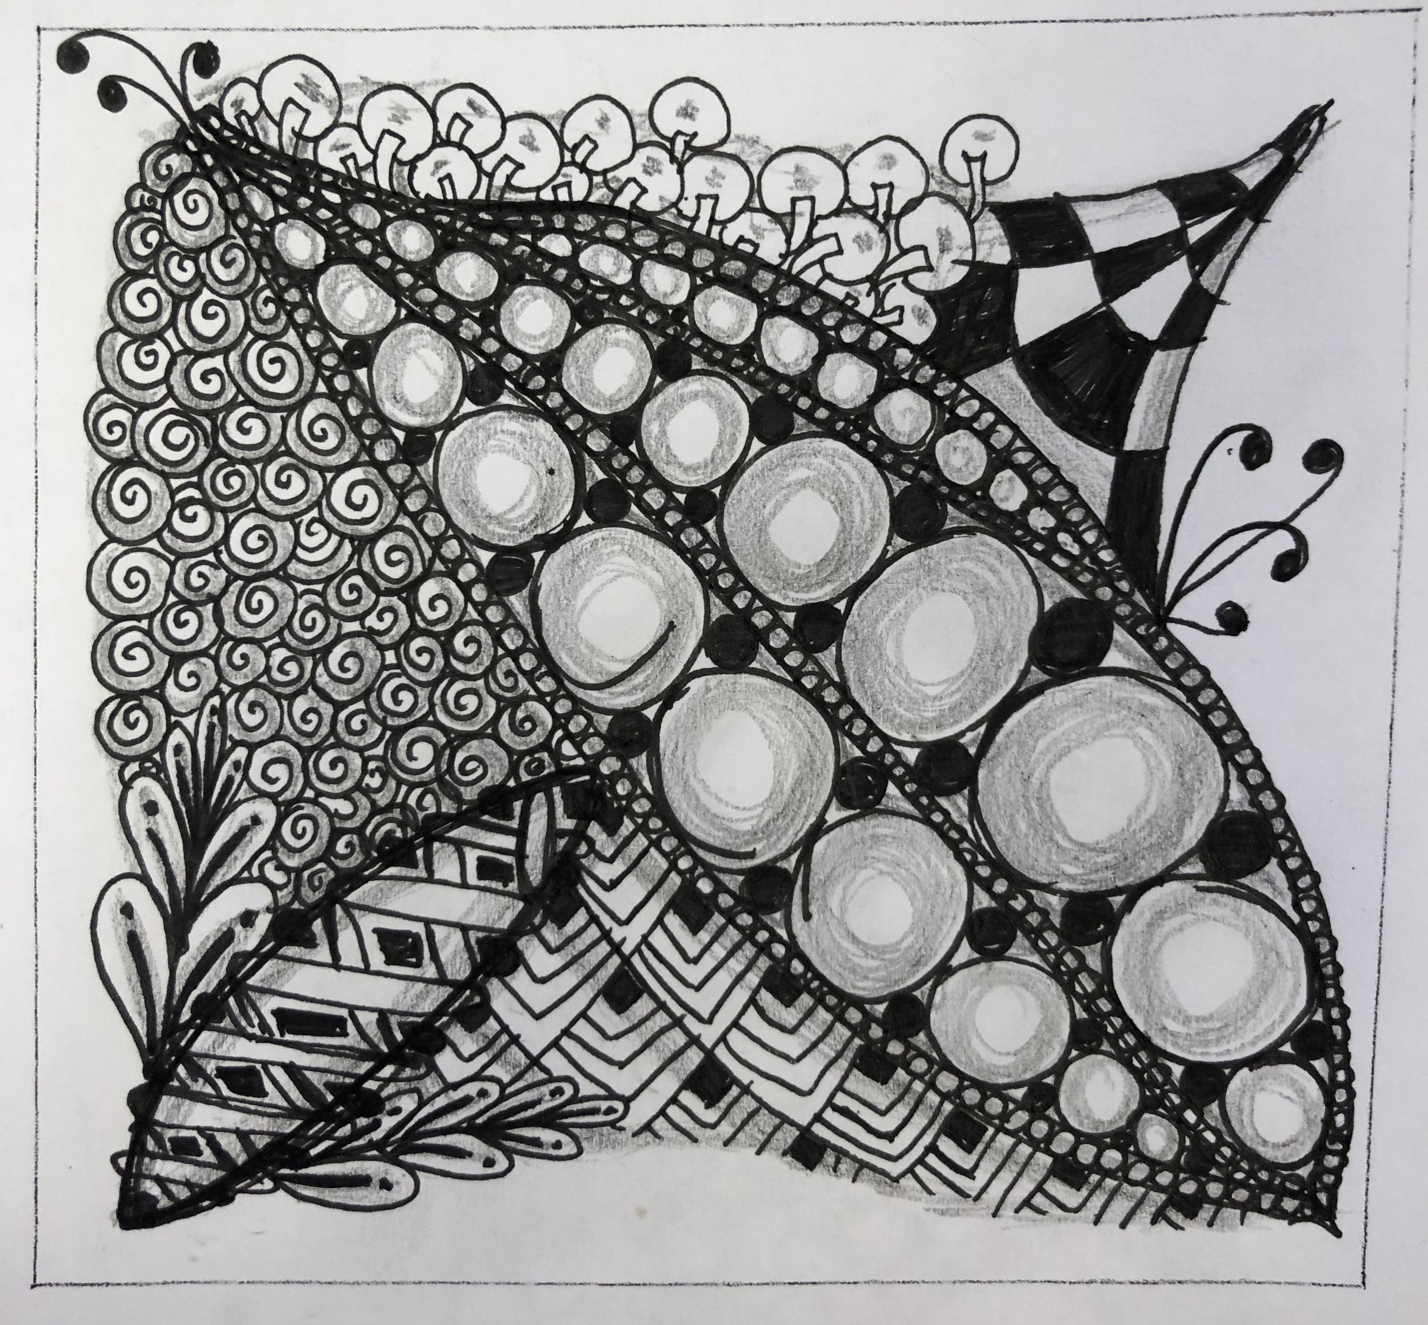

*Figure 1*. Zentangle by Amelia

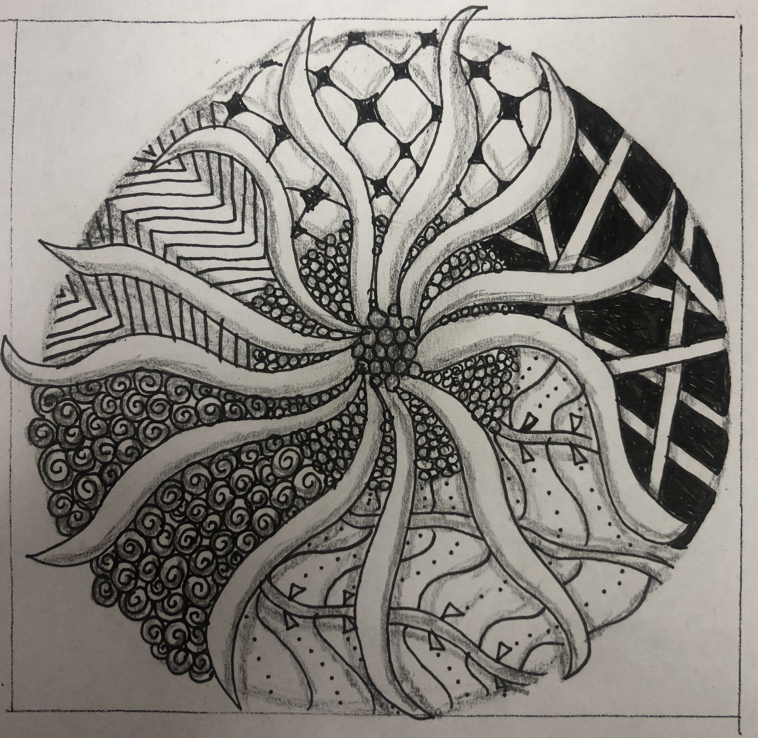

*Figure 2*. Zentangle by Amelia

In response to my experiences with “Zentangle” art, I took up the art of embroidery. Previous to my experiences with “Zentangle”, a majority of my art making was very fluid, loose paintings with acrylic paint or drawings using oil pastels. I had never committed to making art with a pen or pencil, because I hated the idea of making something so hard and concrete. Once I started to experiment with it though, I started to find a new love for concrete images. So when I decided to try embroidery, I found it was similar to Zentangle art because thread is not easily moved or erased, if you decide that you don’t like it later on. I created a couple different styles of embroidery pieces, including different quotes, which are super concrete. In the end, I learned a lot about myself and my skills regarding concrete drawings and art making. I think this experience with “Zentangle” has really expanded my art making skills and has really opened my eyes to other ways of thinking. I also found embroidery to be very therapeutic because it requires a certain amount of focus and flow-like state as well. I always become fully engrossed in each piece. I included photos of the first two embroidery pieces that I ever made, as you can see in Figures 3 and 4 below.

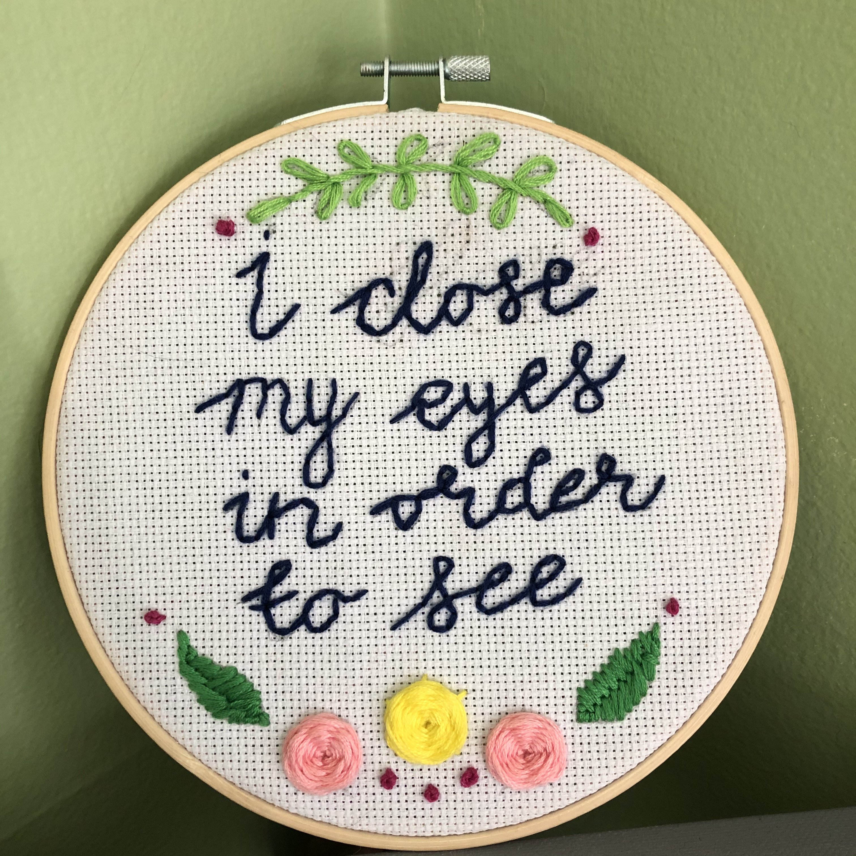

*Figure 3.* Embroidery by Amelia

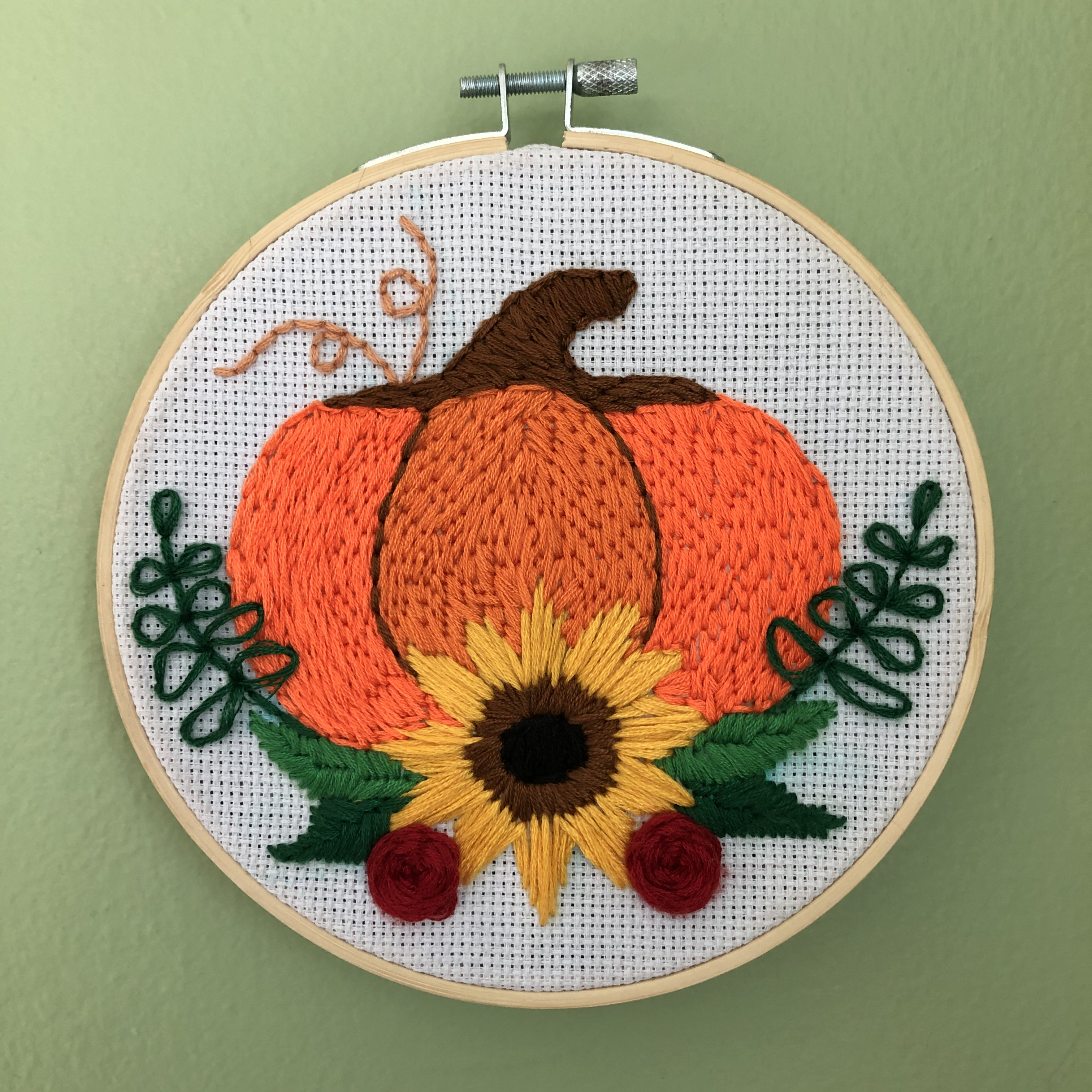

*Figure 4.* Embroidery by Amelia

**Observations**

I also took notes and made many observations while a peer of mine, Ben, created art with me. He always seemed to be in a more relaxed mood after every session. I could kind of see this sense of relief come over him, because he even physically looked more relaxed after each session. I could observe this happen because he always leaned back in his chair after he was done, or threw his pencil down and breathed a deep breath or sigh of relief after he had finished. These actions could all be observed as signs of letting something go. During each session, Ben would always become hyper focused on the “Zentangle” he was making. He wouldn’t talk, unless I said something to him or asked him a question. So, most of the time we just sat in silence, and I had music on in the background. Ben stated that he liked the music on in the background (during an interview) and found it relaxing (Ben, Personal Communication, 2020). During our sessions, both of us would find ourselves singing along to the music or nodding our heads to the beat, because I would keep it on a country station that we both enjoyed. I believe it really added to the comfortable atmosphere. Sometimes after a session, Ben would even tell me that he felt better, and would leave the room with a sense of purpose. With Ben’s permission, I have included a few of the “Zentangles” that he made in session, which can be seen in Figures 5 and 6 below.

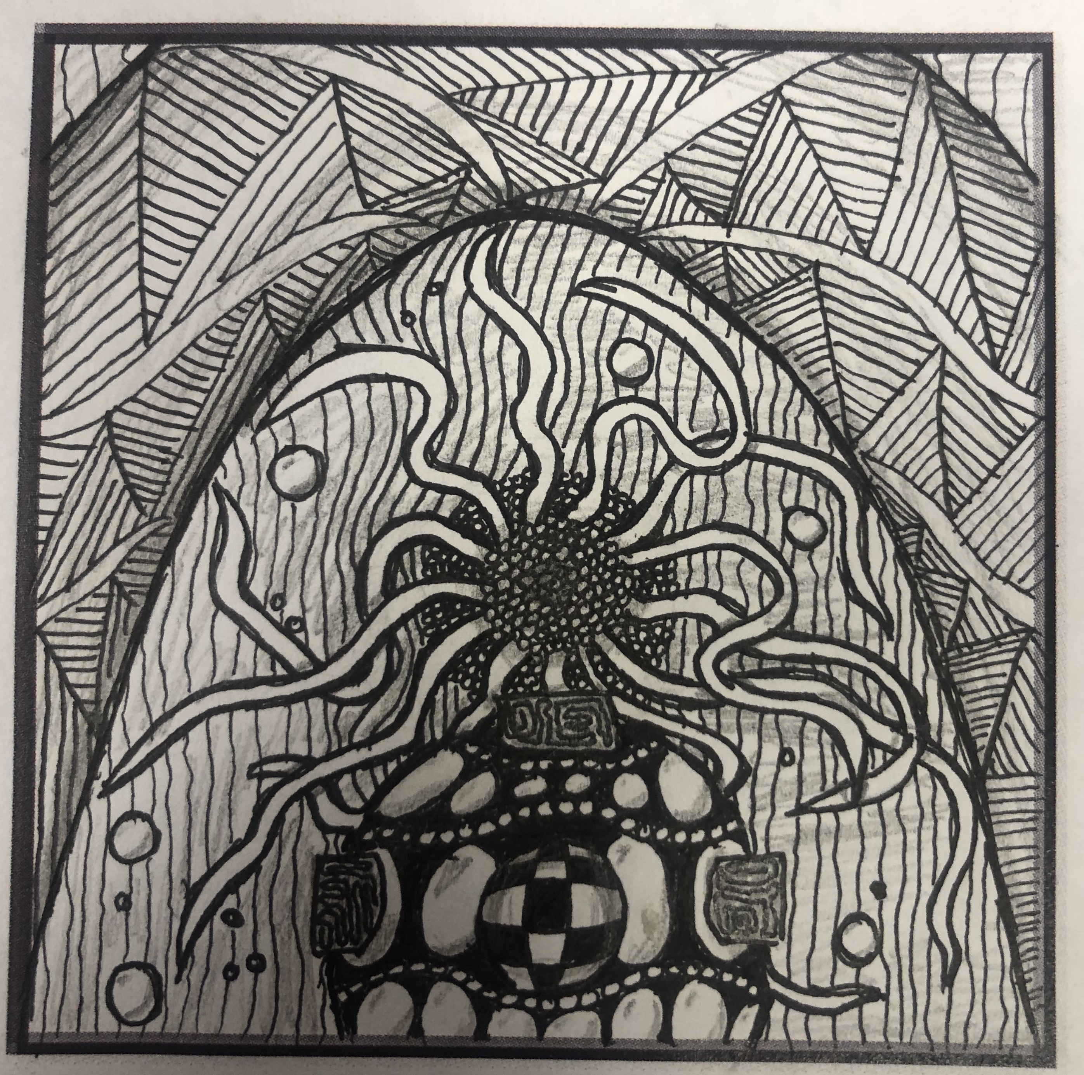

*Figure 5*. Zentangle by Ben

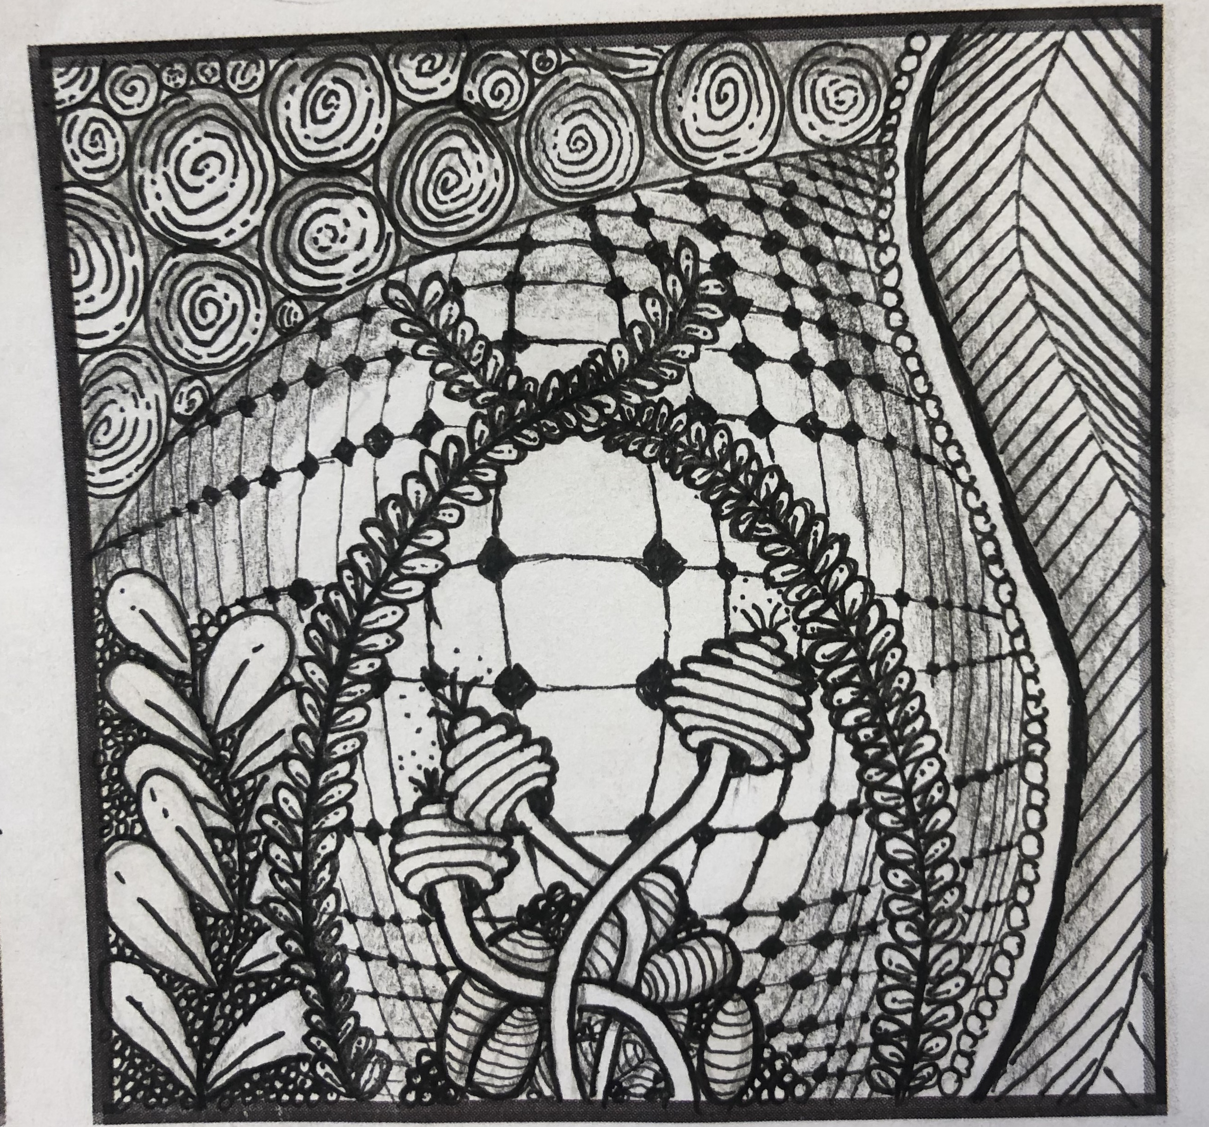

*Figure 6.* Zentangle by Ben

Part of my research into the relevance of “Zentangle” in relation to stress and anxiety was an interview with Ben, who I have been working with in my art-based research journey. I stopped seeing him weekly after a couple of months of “Zentangle” research, but I did get to catch up with him a month or so later to gather his thoughts on the whole experience. Ben reflected positively on the experience, as he was going through the death of both of his parents during his time with me. He stated that “Zentangle” let him “get into a state of flow and concentration, so much so that he was only focused on the art piece in front of him, not all of the other things that were going on in his life” (Ben, Personal Communication, 2020). Ben also reflected on the way he felt after each art therapy session we had. He stated, “after each session, I felt a sense of relief, and also a sense of accomplishment that I had created something” (Ben, Personal Communication, 2020). When I started my art research with Ben, I knew that he wasn’t an artist. In fact, this was his first ever experience with art therapy, and he has very limited experiences with art in general. After doing these exercises with “Zentangle”, he stated that he would “love to continue the art of ‘Zentangle’ and art therapy in the future” and he thought that it was “very beneficial for stressful and anxious situations” (Ben, Personal Communication, 2020). Another interesting thing I found out during this interview was that Ben enjoyed the fact that I, a student in my last year of my Masters in Art Therapy, would make art with him during each session. We were both experimenting with the art of “Zentangle” during this time, so we would both make art during each session. I was doing it for my Master’s research, and he was doing it for stress relief. He stated that “it took the pressure off of the situation that there was someone else who is a little more experienced making art and also kind of showing me what to do” (Ben, Personal Communication, 2020). I found that this interview with Ben really solidified all of the research I had been doing.

**Conclusion**

In summary, art therapy and “Zentangle” art have been shown to reduce feelings of stress and anxiety through mindfulness and distraction techniques. They achieve this by helping take the client’s mind off of their stressful and anxiety provoking situations and help them focus on something else for a while. The concept of art therapy helps reduce these negative feelings while also improving mood. There have been several studies on art therapy and “Zentangle”, but much more research needs to be conducted. This type of research is important and relevant because millions of Americans suffer from stress and anxiety on a daily basis, and a staggering number of them don’t seek treatment. It is possible that new and innovative ways of treatment might evoke Americans to seek treatment for their stress and anxiety more often. More research needs to be conducted.

I believe that more research on specifically group art therapy and anxiety and stress reduction in adults could also be conducted. This is, again, very important in this time period because we are under a global health pandemic. Many more people around the world are under more stress than ever. Many people don’t have jobs, and this time period is being compared to the Great Depression. Not having any income, some people don’t even qualify for unemployment, being confined to our homes, and fearing for one’s health and safety are all things that are very stressful on our bodies and mental health. It is times like this that coping mechanisms are very important. With many non-essential businesses closed, people have to find ways to cope within their own homes. This is why art therapy is so important. One can create art with many things that they already have in their home. Much more research needs to be conducted on art therapy in the next several months. Many people’s well being may depend on it.

References

Abbing, A., Baars, E., Sonneville, L., Ponstein, A., & Swaab, H. (2019). The Effectiveness of Art Therapy for Anxiety in Adult Women: A Randomized Controlled Trial. *Frontiers in Psychology*, *10*.

Abbing, A., Ponstein, A., Hooren, S. V., Sonneville, L. D., Swaab, H., & Baars, E. (2018). The effectiveness of art therapy for anxiety in adults: A systematic review of randomised and non-randomised controlled trials. *Plos One*, *13*(12).

Abbott, K. A., Shanahan, M. J., & Neufeld, R. W. J., (2013). Artistic tasks outperform nonartistic tasks for stress reduction. *Art Therapy*, 30(2, 71-78.

About the zentangle method. (n.d.). Retrieved from https://zentangle.com/pages/about-the-zentangle-method

American Institute of Stress [AIS]. (2019). 42 Worrying Workplace Stress Statistics. Retrieved from https://www.stress.org/42-worrying-workplace-stress-statistics

Anxiety and Depression Association of America [ADAA]. (2018). Facts & Statistics: Anxiety and Depression. Retrieved from https://adaa.org/about-adaa/press-room/facts-statistics.

Ashlock, L., Miller-Perrin, C., & Krumrei-Mancuso, E. (2018). The effectiveness of structured coloring activities for anxiety reduction. *Art Therapy*, 35(4), 195-201.

Chambala, A. (2008). Anxiety and art therapy: Treatment in the public eye. *Art Therapy*, 25(4), 187-189.

Flett, J., Lie, C., Riordan, B. C., Thompson, L. M., Conner, T. S., & Hayne, H. (2017). Sharpen your pencils: Preliminary evidence that adult coloring reduces depressive symptoms and anxiety. *Creativity Research Journal*, 29(4), 409-416.

Hofmann, S. G., Sawyer, A. T., Witt, A. A., & Oh, D. (2010). The effect of mindfulness-based therapy on anxiety and depression: A meta-analytic review. *Journal of Consulting and Clinical Psychology, 78*(2), 169-183.

Jaret, P., Tucker, A., Kuyken, W., Hunter, J., Sofer, O., Bullock, G., & Newman, K. (2019). What is Mindfulness? Retrieved from https://www.mindful.org/what-is-mindfulness/.

Kao, H. S., Zhu, L., Chao, A. A., Chen, H. Y., Liu, I. C., & Zhang, M. (2014). Calligraphy and meditation for stress reduction: an experimental comparison. *Psychology research and behavior management*, *7*, 47.

Khoury, B., Sharma, M., Rush, S. E., & Fournier, C. (2015). Mindfulness-based stress reduction for healthy individuals: A meta-analysis. *Journal of psychosomatic research*, *78*(6), 519-528.

Krahula, R. (2012). *One zentangle a day: a 6-week course in creative drawing for relaxation, inspiration, and fun*. Beverly, MA: Quarry Books.

Lee, S. (2018). Why color mandalas? A study of anxiety-reducing mechanisms. *Art Therapy : Journal of the American Art Therapy Association, 35*(1), 35-41.

Marchand, W. R. (2012). Mindfulness-based stress reduction, mindfulness-based cognitive therapy, and zen meditation for depression, anxiety, pain, and psychological distress. *Journal of Psychiatric Practice®*, *18*(4), 233-252.

Noor, S. M., Saleem, T., Azmat, J., & Arouj, K. (2017). MANDALA-COLORING AS A THERAPEUTIC INTERVENTION FOR ANXIETY REDUCTION IN UNIVERSITY STUDENTS. *Pakistan Armed Forces Medical Journal,* (6), 904-907.

Schwarzer, S., Miller, E., Rountree, C., Nehru, N., Kaur, T., Raju, P., Humphrey, N. (n.d.). American University of the Caribbean School of Medicine.